

**LoRa-Enabled Smart Traffic Management System**

**Course Code:** CNG 476 System Simulation

**Semester/Year:** Spring 2024/2025

**Assignment Type:** Progress Report

**Date Given:** Sunday 9 March 2025

**Instructor:** Assf. Prof. Dr. Muhammad Toaha R. Khan

**Team Members:**

Boğaçhan Ayar 2486967

Berkay Ersöz 2551257

**Proposal**

This project aims to design and simulate a **smart traffic management system** using **Omnet++ and the Flora framework** to optimize the light usage when the drivers are in a crossroad intersection.

In this project, we are investigating the situation of traffic lights that are placed in the cross roads. Each road will have its own traffic light and with the help of the camera sensors, we are trying to achieve the best and the safest way to manage traffic.

First of all, camera sensors will detect how many cars are waiting in each intersection. After the camera sensors make the calculation of how many cars are present in each one, it will represent which light is the most optimal one to make it turn green.Then, the control office will turn the lights to the necessary color accordingly.

By using poisson distribution which is used for modelling random events over time, we can simulate the traffic flow and obtain a certain probability of number of cars arrived in a specific interval. For each simulation cycle, a random number of arrivals will be generated.

Also to enhance the accuracy of the simulation, the project will incorporate **Monte Carlo simulations for modeling vehicle arrivals, probability models for traffic flow analysis, and stochastic processes for signal transition probabilities**. This simulation will help evaluate **network reliability, congestion control efficiency, and the impact of LoRa-based communication on smart city traffic systems**.

Figure 1 Traffic Management with Lora

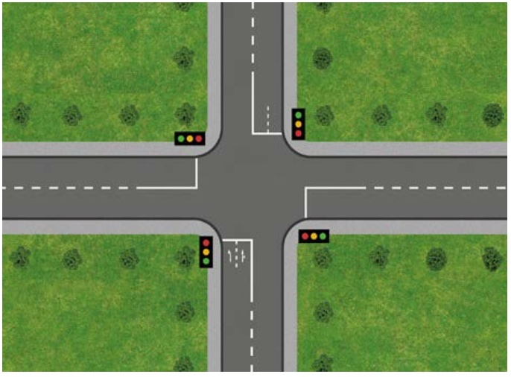

Figure 1 Traffic Management with Lara

**Project Progress**

**Model**

A general representation of a smart traffic management system at a crossroad intersection. In this simulation the traffic lights are dynamically controlled according to the amount of vehicles captured by the camera sensors. The data we got from this scenario will help us later on for simulation of the particular situation with the help of Omnet++.

**System**

* There will be n number of vehicle arrivals at an intersection.
* The detection of n vehicles will be done by the camera sensors.
* There will be communication of sensor data over LoRa.
* Depending on the light changes, the vehicle flow will be affected.

**System State**

* Number of vehicles on each road.
* Light status (green/red) at each intersection.
* Message sensor that delivers the current light status of each road to control unit, which leads to the correct flow of vehicles.
* Amount of time passed since the last light status change.

**Entity**

* Vehicles.
* Traffic Lights.
* Camera Sensor.
* Control Unit.
* LoRa Gateway and Node.

**Attributes**

* **Vehicle** = Arrival time, position, speed, wait time.
* **Traffic Light** = Current status, time duration.
* **Camera Sensor** = Road id, detection interval, transmission delay, vehicle queue length detection.
* **Control Unit** = Algorithm state, last decision time, communication latency.
* **LoRa Node** = message queue, transmission rate.

**List**

* **Vehicle Queue** = Number of vehicles waiting ordered by their arrival time.
* **Event List** = Events that could happen in the future such as vehicle arrival, light change and message transmission.
* **Sensor Report Queue** = Queue of messages waiting to be sent or processed.

**Event**

* Arrival of a new vehicle at road.
* Camera sensor capturing the vehicle count.
* Transmission of a sensor message via LoRa.
* Reception of a message by the Control Unit (CU).
* Traffic light switching from red to green.

**Activity (Unconditional Wait)**

* A traffic light stays green for 30 seconds.
* Camera sensor reports count every 5 seconds within a certain distance.
* Message transmission over LoRa with fixed time.

**Delay (Conditional Wait)**

* A vehicle waiting for the green light.
* A sensor node waiting for a free channel to transmit MAC Protocols.
* Control Unit (CU) waiting for all sensor inputs before making a decision.

**Clock**

* For tracking the occurrence of an event.
* We consider time as discrete for allowing the advancing from one event to the next in simulation order.

**Milestones Achieved**

**April 14 - April 29**

**Berkay:**

* Defined system components: vehicles, sensors, lights, Control Unit(CU), LoRa communication.
* Established simulation attributes, entities, system state variables, and event types.
* Researched Omnet++ event-based simulation mechanics.

**Bogachan:**

* Listed unconditional and conditional waits for delay modeling.
* Finalized modeling assumptions: vehicle behavior, sensor intervals, LoRa delays.
* Researched Omnet++ event-based simulation mechanics.

**April 29 – May 4**

**Collaborative Work (Berkay & Bogachan)**

* Worked together on preparing the documentation for the progress report.
* Structured the report sections based on CNG 476 requirements.

**Code**

**TrafficSimulation.ned**

network SmartTrafficSim

{

submodules:

road1: TrafficNode {

parameters: roadId = 1;

}

road2: TrafficNode {

parameters: roadId = 2;

}

road3: TrafficNode {

parameters: roadId = 3;

}

road4: TrafficNode {

parameters: roadId = 4;

}

control: ControlUnit;

connections allowunconnected:

road1.loraOut --> control.loraIn++;

control.loraOut++ --> road1.loraIn;

road2.loraOut --> control.loraIn++;

control.loraOut++ --> road2.loraIn;

road3.loraOut --> control.loraIn++;

control.loraOut++ --> road3.loraIn;

road4.loraOut --> control.loraIn++;

control.loraOut++ --> road4.loraIn;

}

**TrafficNode.ned**

simple TrafficNode

{

parameters:

int roadId;

gates:

input loraIn;

output loraOut;

}

**ControlUnit.ned**

simple ControlUnit

{

gates:

input loraIn[];

output loraOut[];

}

**TrafficSimulation.h**

#ifndef __SMARTTRAFFICSIM_TRAFFICSIMULATION_H_

#define __SMARTTRAFFICSIM_TRAFFICSIMULATION_H_

#include <omnetpp.h>

using namespace omnetpp;

class TrafficNode : public cSimpleModule

{

private:

int roadId;

int queueLength;

cMessage *sensorReportEvent;

protected:

virtual void initialize() override;

virtual void handleMessage(cMessage *msg) override;

void sendSensorData();

};

class ControlUnit : public cSimpleModule

{

private:

std::map<int, int> roadQueues;

cMessage *decisionEvent;

int currentGreen;

protected:

virtual void initialize() override;

virtual void handleMessage(cMessage *msg) override;

void updateLightStates();

};

#endif

**TrafficSimulation.cc**

#include "TrafficSimulation.h"

Define_Module(TrafficNode);

Define_Module(ControlUnit);

// Traffic Node

void TrafficNode::initialize() {

roadId = par("roadId");

queueLength = intuniform(1, 10);

sensorReportEvent = new cMessage("sensorReport");

scheduleAt(simTime() + 5, sensorReportEvent);

}

void TrafficNode::handleMessage(cMessage *msg) {

if (msg == sensorReportEvent) {

sendSensorData();

scheduleAt(simTime() + 5, sensorReportEvent);

} else {

// Handle light status update if needed

delete msg;

}

}

void TrafficNode::sendSensorData() {

cMessage *report = new cMessage(("SensorReport-" + std::to_string(roadId)).c_str());

report->addPar("roadId") = roadId;

report->addPar("queueLength") = queueLength;

send(report, "loraOut");

}

// Control Unit

void ControlUnit::initialize() {

decisionEvent = new cMessage("decision");

currentGreen = -1;

scheduleAt(simTime() + 10, decisionEvent);

}

void ControlUnit::handleMessage(cMessage *msg) {

if (msg == decisionEvent) {

updateLightStates();

scheduleAt(simTime() + 10, decisionEvent);

} else {

int roadId = msg->par("roadId");

int qLen = msg->par("queueLength");

roadQueues[roadId] = qLen;

delete msg;

}

}

void ControlUnit::updateLightStates() {

int maxRoad = -1, maxQ = -1;

for (auto& pair : roadQueues) {

if (pair.second > maxQ) {

maxQ = pair.second;

maxRoad = pair.first;

}

}

for (int i = 0; i < 4; i++) {

cMessage *lightMsg = new cMessage("LightStatus");

lightMsg->addPar("roadId") = i + 1;

lightMsg->addPar("light") = (i + 1 == maxRoad) ? "green" : "red";

send(lightMsg, "loraOut", i);

}

currentGreen = maxRoad;

roadQueues.clear();

}

for (int i = 0; i < gateSize("loraOut"); i++) {

cMessage *lightMsg = new cMessage("LightStatus");

lightMsg->addPar("roadId") = i + 1;

lightMsg->addPar("light") = (i + 1 == maxRoad) ? "green" : "red";

send(lightMsg, "loraOut", i);

}

currentGreen = maxRoad;

roadQueues.clear();

}

**References**

[1] A. Varga, "The OMNeT++ Discrete Event Simulation System," in Proceedings of the European Simulation Multiconference (ESM'2001), Prague, Czech Republic, Jun. 2001. [Online]. Available: <https://omnetpp.org>

[2] Semtech Corporation, "LoRa and LoRaWAN: A Technical Overview," 2021. [Online]. Available: <https://lora-alliance.org>

[3] <https://www.drivejohnsons.co.uk/learning-centre/how-to-drive-a-car/cross-roads/>